Highlights and glitter

Jane went into a stationery shop. Her dad gave her £10 to spend.

She wanted to buy some highlighters costing 24p each and glitter pens at 25p each.

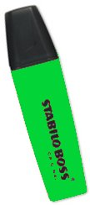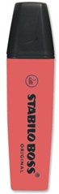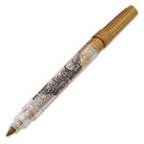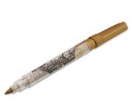

She bought three times as many highlighters as glitter pens and received £4.18 change.

How many of each did Jane buy?

